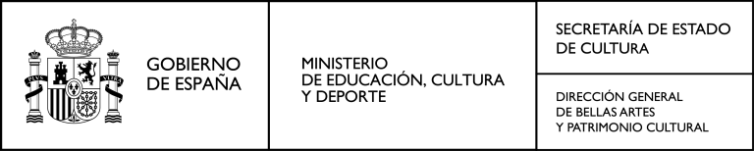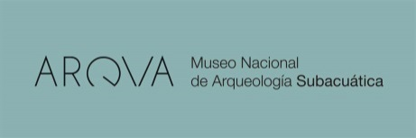

PRIMER CONGRESO INTERNACIONAL "LA ARMADA ESPAÑOLA DE 1588
Y LA CONTRA ARMADA INGLESA DE 1589. EL CONFLICTO NAVAL ENTRE ESPAÑA E INGLATERRA: 1580-1607"

I INTERNATIONAL CONGRESS
"THE SPANISH ARMADA OF 1588
AND THE ENGLISH COUNTER ARMADA OF 1589.
NAVAL CONFLICT BETWEEN SPAIN AND ENGLAND: 1580-1607"

PRESENTATION PROPOSALS

Title Author 1
Author 2
Author 3

DATA OF THE MAIN AUTHOR (the organization will maintain correspondence only with this person) Name
Surname Address Country e-mail Telephone
Institution/ Company

Please, write clown a brief abstract of your communication, max. 250 words and send this file to: informacion.arqua@mecd.es

PASEO DEL MUELLE A LFONSO XII, nº22 30202 - CARTAGENA (MURCIA)
TEL.: + (34) 968 12 11 66
FAx: +(34) 968 12 11 89

